广西民族师范学院
Guangxi Normal University for Nationalities

2020届毕业生自荐材料
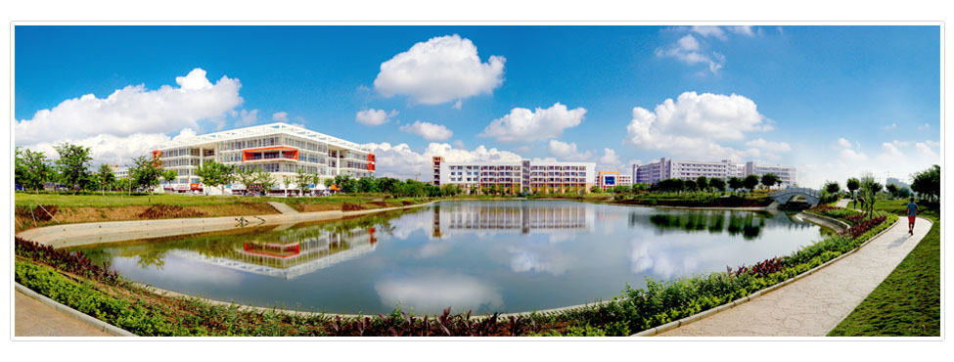

姓名：余丽萍
专业：英语
学历：本科
电话：18376417915
Email:2691541614@qq.com

广州市源途文化用品有限公司招聘简章

招聘职位：文具销售省区经理
工资：6000-12000元/月
地址：广州-白云 | 销售 | 学历不限 | 经验不限 | 招3人
五险一金 包住 交通补助 饭补
职位简介
岗位职责：
1、对市场及客户进行开拓、沟通与管理，制定合作方案；
2、执行销售和市场推广方案，完成销售目标；
3、制定渠道策略，提供渠道服务支持；
4、及时沟通客户，反馈市场信息，做出处理意见；
5、协助销售总监开拓、沟通和管理各区域的重要客户；
6、处理其他事宜。

任职要求：
1、快消品三年以上业务经验；
2、有一定的销售团队管理经验；
3、优秀的业务能力和个人魅力。
4、能适应长期出差！
5、有文具行业经验，熟悉全国市场优先。

截止日期：2019年5月23日-6月30日
RESUME
Chinese Name | Yu Liping | Sex | Female | Birth Place | Hezhou  Guangxi  Province
Telephone | 18376417915 | E-mail | 2691541614@qq.com | Birth Date | 1997.9
University | Guangxi Normal University for Nationalities |  |  | Major | English
Job Objective | Foreign trade Sales Manager
English Proficiency | Good command of both written English CET 4 and fluent spoken English
Computer Skills | Skilled in solving actual problem with Excel,PPT and Word
Work Experience | - Successful experience:  - 2017:Do a summer job in Tianyu Company  - 2018:Work in EVERWIN Company  - During the school days : Do some part-time jobs  There’s no doubt that I’ve learned too much from these activities. And I’m sure that the experience (the spirit of teamwork and the skill of handling with interpersonal relations) will be helpful in the future work.
Main Courses | - Practice of International Trade Business English Interpretation  - International Business Documentation Intercultural Business Communication  - Marketing Management Business English Translation  - Business English Comprehensive Course Japanese
Scholarships and Awards | National Computer Rank Examination Grade I Certificate
Self-  Evaluation | - Familiar with the basic knowledge of international trade  - Good communication skills and teamwork spirit  - Good adaptation to new environment and new things  - Be diligent, outgoing and responsible for my work  - Respond well in high-pressure atmosphere

2020届毕业生就业推荐表
基本  情况 | 姓 名 | 余丽萍 | 性 别 | 女 | 民 族 | 汉
 | 出生年月 | 1997.09 | 政治面貌 | 共青团员 | 籍 贯 | 广西贺州
 | 在校期间任职情况 |  | 大一任班级体育委员
教育  背景 | 专 业 | 英语 |  |  | 毕业年月 | 2020.6
 | 学历、学位 | 文学学士 |  |  | 外语语种 | 英语、日语
 | 外语水平 | 大学英语四级564分 |  |  | 计算机水平 | 全国计算机等级考试一级
专长 | 跑步，球类运动和作文写作
在校  期间  获得  奖励 | 普通话水平测试二级甲等  第四节田径运动会4x100女子组第六名
在校  期间  社会  实践  情况 | 2017年暑假在天宇有限公司工作了两个月  2018年在长盈电子有限公司工作了一个月  2018-2019在教育机构做家教，辅导学生英语  2018年11月份去凭祥综合保税区见习
综合素质评价 | 学院盖章： 年 月 日
学校  推荐  意见 | 盖章： 年 月 日
联系方式 | 毕业生 | 通讯地址 | 广西崇左市广西民族师范学院 |  |  | 邮 编 | 532200
 |  | 电子邮箱 | 2691541614@qq.com |  |  | 电 话 | 18376417915
备注：学业成绩请以学校教务处签章的成绩单为准（附背面）。
承诺：本人承诺该表所填内容真实、准确。如有不真实、不准确，本人愿意承担由此而产生的后果。

毕业生签名（手写）：

学习成绩单
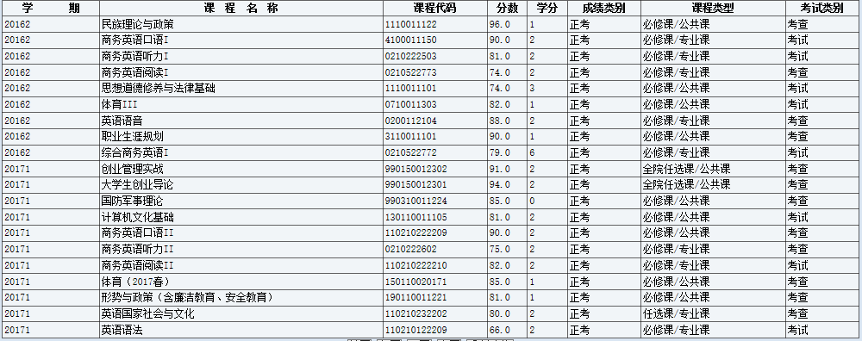
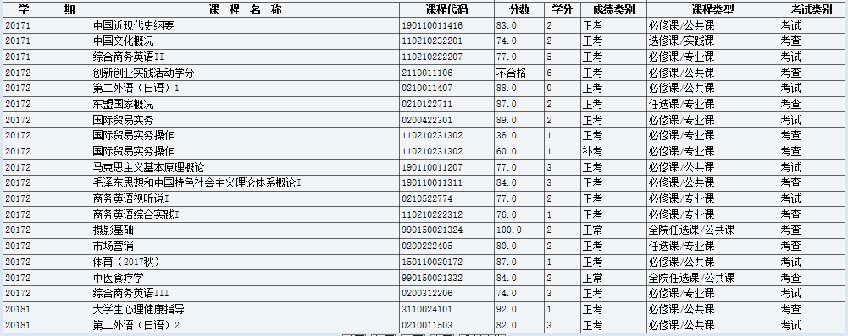
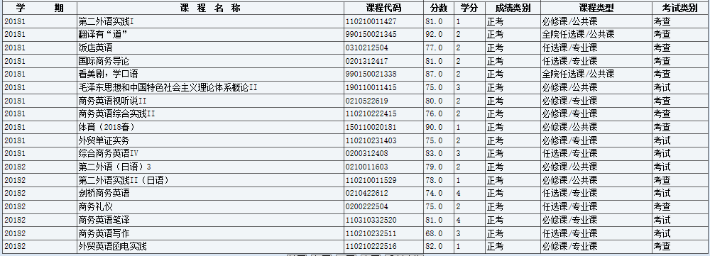
获奖证书

