简 历
Chinese Name  中文姓名 | WEIJinxun  韦金汛 |  | Sex  性别 | Female  女 |  | Date of birth  出生年月 |  | April 20th,1998  1998.04.20 | 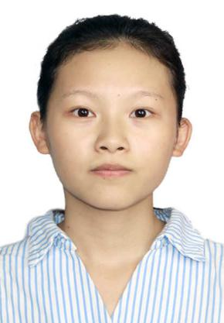
Native Place  籍贯 |  |  | Heng County,Guanxi Province  广西横县
Telephone  联系方式 |  | 13377147540 |  |  | Email  电子邮箱 |  | 2271640715@qq.com
Objective  应聘职位 |  | Interpreter of business English  商务英语翻译员
Education  教育背景 |  | September,2016-June,2020 Guangxi Normal University for Nationalities  2016.09-2020.06 就读于广西民族师范学院  Bachelor Degree Major in Business English  本科学历 专业：商务英语  Specialist subjects:English Grammar,Translation,Oral English,English Writing,International Trade Affairs  专业科目：英语语法，翻译，英语口语，英语写作，国际贸易实务
Qualifications  资历 |  | Pass CET6/NCRE Level 1  通过大学英语六级/计算机一级考试  Fluent in oral English and Japanese and skilled in written English  英语和日语口语流利，擅长英语写作  Good working knowledge of Microsoft Word and Excel Spreadsheets  熟练使用Word和Excel软件
Job Experience  工作经历 |  | July,2018-March,2020  2018.07-2020.03  Worked in JinHaiYan Foreign Trade Company as an interpreter in internship  实习期在金海燕外贸公司担任翻译员
Awards  获奖情况 |  | 2018 Passed The China National Business English Test (Level Two)  2018 通过全国国际商务英语考试（二级）  2018 Got Commercial Vocational Skills Certificate  2018 获商务人员职业技能证书  2017 Got the First prize in the English Writing Competition  2017 获英语写作比赛一等奖
Self-evaluation  自我评价 |  | 1.Confident, eloquent ,outgoing,full of energy  自信，口才好，外向，精力充沛  2.Having a teamwork spirit，good adaption to new work and new environment，be responsible for my work  有团队精神,能快速适应新工作和环境,有责任心

